Marketing Campaign to Discover Prime Contact Opportunities – User Guide

[Link to Dashboard](https://prod-uk-a.online.tableau.com/#/site/qaltd/views/MarketingCampaignv3/Dashboard3?:iid=2)

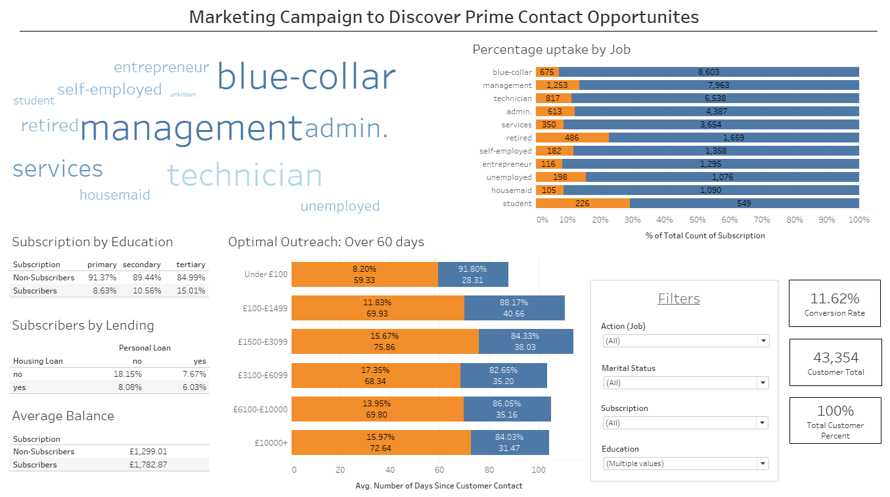

Welcome to the user guide for the Prime Contact Opportunities dashboard. This guide will walk you through the features and functionalities of this dashboard, helping you make the most of it.

1. **Logging in**:

* Start by logging into the dashboard on the link above using your credentials provided by your administrator.

1. **Dashboard Overview**:

* Upon logging in, you will be directed to the dashboard landing page.
* The Prime Contact Opportunities dashboard provides a comprehensive view of the contact strategy relating to different aspects of customers lives. This is broken down into age bracket, employment, education, balance, optimal outreach time and current lending.

1. **Navigation**:

* The dashboard is a one0page dashboard with all information in one place.

1. **Data Visualisation and Interactivity**:

* The Prime Contact Opportunities dashboard presents data in visual formats; word cloud, bar charts, text tables and important information highlight cards
* Interact with the visualisations by following these instructions:

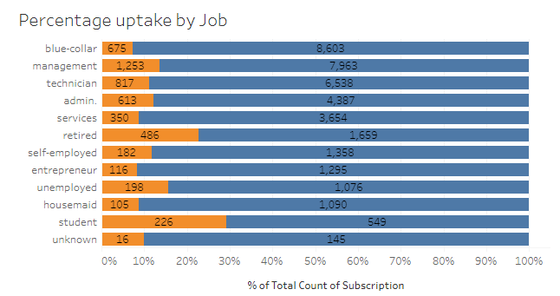

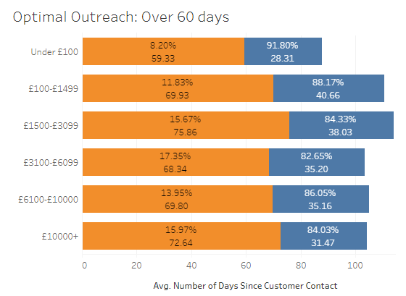

**Bar charts**: hover over the different parts of the bar chart to see a tooltip pop up containing a highlight table. The left visualisation highlight table reveals whether they were subscribers, that total count of subscription and the percentage total in subscriptions for that job role. The right visualisation highlight reveals whether they were subscribers, the average time between contacts and the percentage total for that balance bracket.

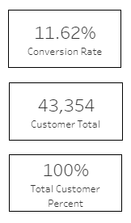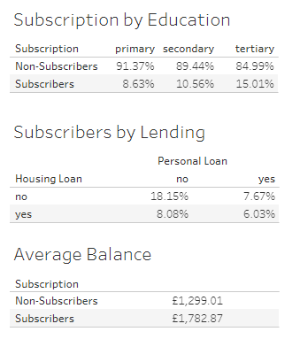

**Text tables and Information Cards**: highlight the percentage of subscribers and important information for each area, these update depending on the filters chosen.

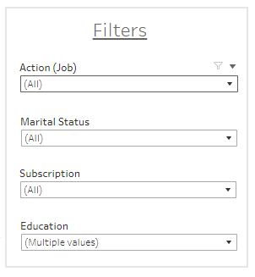

**Filters**: click the dropdown and highlight all relevant fields to narrow down the data